Abdul Haseeb

20F-1066 | BSE-7A

Summary Report

TASK - 2

**Setting Up Odoo Locally**

# Clone Repository

* Cloned the GitHub repository by the following command: git clone https://github.com/odoo/odoo.git

# Install Dependencies

* Installed python and pip library on my computer.
* Installed PostgreSQL database on my computer.

## **Screenshots**

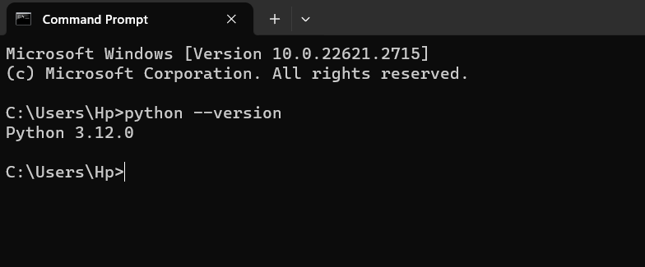

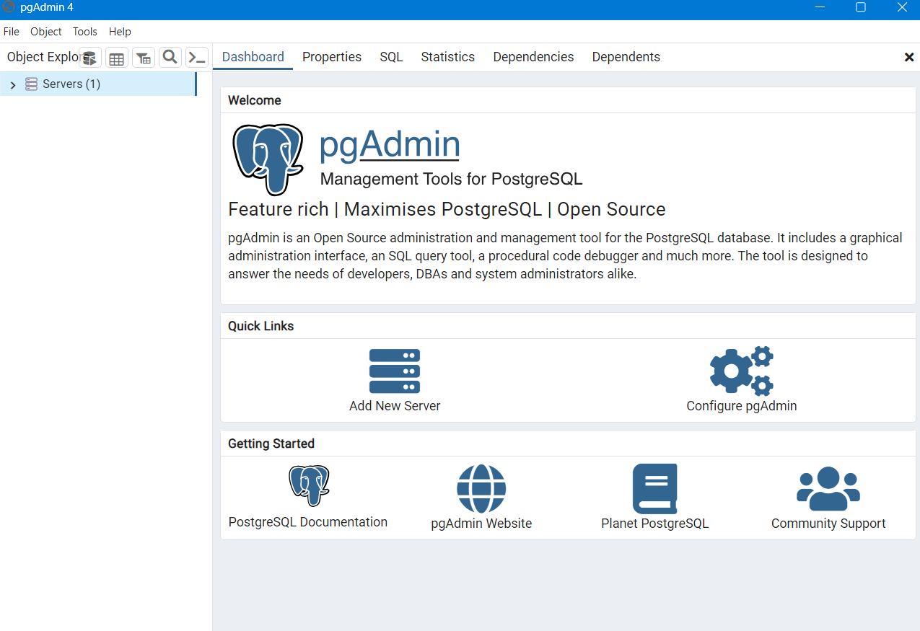

# Run Application

Run the application by executing the following command: python odoo-bin -r dbuser -w dbpassword --addons-path=addons -d mydb

* User name and password is set in the PostgreSQL database.

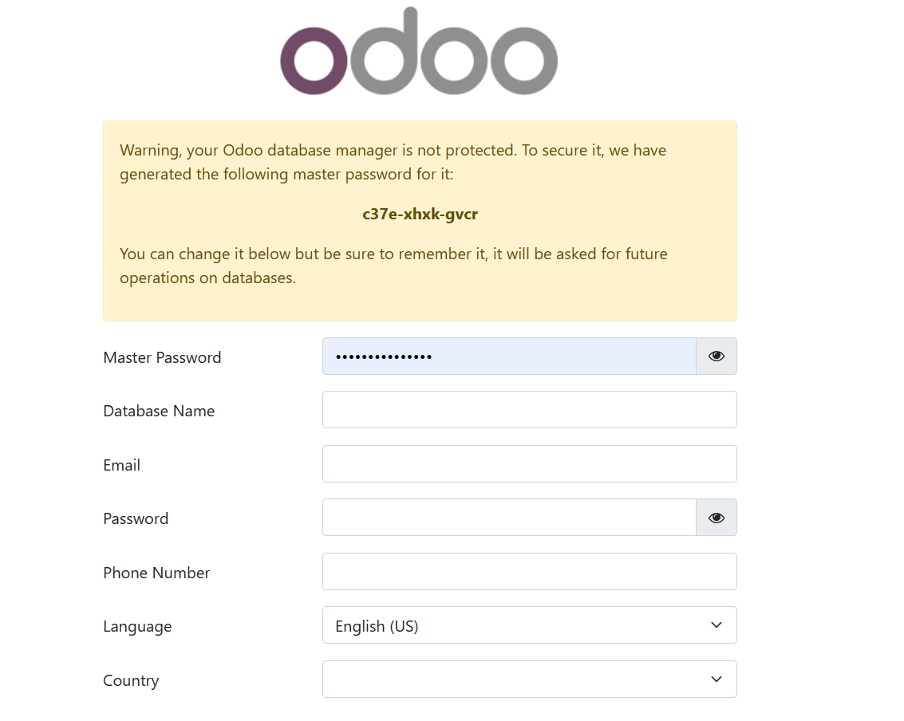

# **Running App Screenshots**



